URPERCENTILE
Visit : http://www.urpercentile.com/
Preparing for entrance exam for top Management Institute ?
Join Us.

HURDLE 41 :

Q1 to Q6 are based on the following graphs
One of the graph below represent the market share of five different brands of T.V sold in a particular city. The total number of TV sold was 25,000.
The other one shows the unit sales price and the Tax the brand is subjected to. Tax is calculated on the sales price.

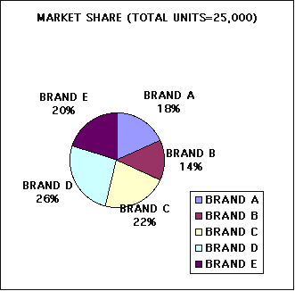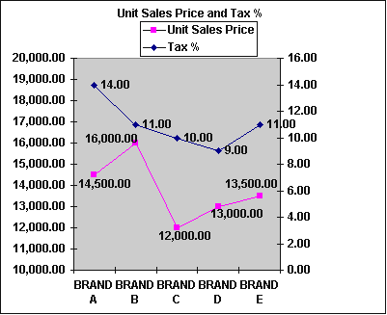

Q1. What is the difference in number of units sold by the most popular brand and the second most popular brand ?
Q2. Which Brand earned the maximum revenue before Tax ?
Q3. Which Brand earned the maximum revenue after Tax ?
Q4. Which Brand had to pay the Maximum Tax ?
Q5. The number of units sold of Brand A increased by 900 units in the next year, but the Market share of each Brand including Brand A remained the same. What would be the new total number of units sold.
Q6. Which one of the following is true :
a) The Brand which sold the maximum number of units paid the maximum Tax
b) The Brand with highest unit cost paid the maximum Tax
c) The brand with highest sales revenue before tax paid the maximum tax.
d) The brand with highest Tax % paid the maximum Tax.

http://www.urpercentile.com/

Q7 to Q12 are based on the following graph.
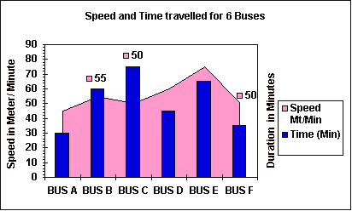

http://www.urpercentile.com
The graph represent the Speed and the time traveled by 6 buses. The speed is given in Meters / Minute and the time is given in minutes.

Q7. Which Bus traveled the maximum distance ?
Q8. Which Bus traveled the minimum distance ?
Q9. If a driver travels more than 3.5 Km with a average speed of more than 48 Mt/ Sec, he has to pay a penalty. How many drivers have to pay penalty?
Q10. If all of the buses start at the same time , which bus will reach its destination first ?
Q11. Which one of the following is true :
a) The Bus with Minimum speed traveled 2 Km less than the one with the highest speed.
b) There are 2 buses that traveled more than 4 Km.
c) There are two buses that traveled less than 2 Km.
d) Both b and c .
Q12. Bus A and F charge Rs. 10 for each passenger , Bus D charges Rs 15 per passenger and the remaining buses charge Rs. 20 for each passenger. Which bus charges the minimum for each Km traveled?

http://www.urpercentile.com
Q13 to Q 18 are based on the following Table providing information about 2 trains running between Dehradun and Delhi.

 | Arrival / Departure TIME-Train 1 | Arrival / Departure TIME-Train 2 | DISTANCE FROM DEHRADUN (Km)
DEHRADUN (Dep) | 17:00 | 09:05 | 0
HARIDWAR (Arr) | 18:05 | 10:15 | 52
HARIDWAR (D) | 18:10 | 10:24 | 52
ROORKEE (A) | 18:48 | 11:10 | 98
ROORKEE (D) | 18:50 | 11:14 | 98
SAHARANPUR (A) | 19:40 | 11:55 | 133
SAHARANPUR (D) | 20:00 | 12:05 | 133
MUZAFFARNAGAR (A) | 20:35 | 12:45 | 192
MUZAFFARNAGAR (D) | 20:37 | 12:50 | 192
MEERUT CITY (A) | 21:16 | 13:35 | 246
MEERUT CITY (D) | 21:18 | 13:38 | 246
NEW DELHI (A) | 22:45 | 14:55 | 320

Q13. Which Train takes longer time to cover the distance and by how much?
Q14. If both the train depart at same time from Dehradun, from which other station will they depart at the same time if all the traveling duration and halting duration are same for both the trains.
Q15. Distance between which two station is the least ?
Q16. Which train halts for maximum duration and where ?
Q17. Both the train start there journey back to Dehradun from Delhi after an halt of 30 minutes of their arrival. How much time does a man stay in Delhi if he arrives by Train 1 and leaves by the next available Train of the two, if he need to spend at least 4 hours in Delhi.
Q18. If an engineering student from Rorkee need to travel back home to New Delhi, which train should he take to minimise his travel time.

http://www.urpercentile.com/

MATCH THE WORDS IN SET A WITH THEIR MEANINGS IN SET B

SET A: 19. Betrothal, 20 Collusion , 21. Pyromania, 22. Carouse, 23. Recondite, 24. Earthenware

SET B:
A. Plumpness.
B. To drink heavily in group and become noisy.
C. Abstruse or secret
D. A ill mannered person.
E. Calling names
F. Any natural substance found below the top surface of Earth.
G. Made of clay and baked in a kiln or dried in the sun.
H. The act or state of being Engaged to someone for marriage.
I. Doing something though you are not happy to do it.
J. A intensive urge or desire to climb pyramids.
K. A secret agreement among two or more people for a wrongful purpose. .
L. An urge to set things on fire.

http://www.urpercentile.com/

